**PIZZA Sales SQL Queries**

A KPI’s

1. SELECT SUM (total_price) AS Total_Revenue

FROM pizza_sales

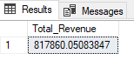

1. SELECT SUM (total_price) / COUNT (DISTINCT order_id) AS Average_order_value

FROM pizza_sales

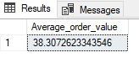

1. SELECT SUM (quantity) AS Total_pizza_sold

FROM pizza_sales

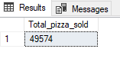

1. SELECT COUNT (DISTINCT order_id) AS Total_order

FROM pizza_sales

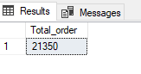

1. SELECT CAST (CAST (SUM (quantity) AS DECIMAL (10,2)) / CAST (COUNT (DISTINCT order_id)

AS DECIMAL (10,2)) AS DECIMAL (10,2)) AS Avg_pizza_per_order

FROM pizza_sales

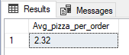

**B. Daily Trend for Total Orders**

1. SELECT DATENAME (DW, order_date) as Order_day, COUNT (DISTINCT order_id) AS Total_orders

FROM pizza_sales

GROUP BY DATENAME (DW, order_date)

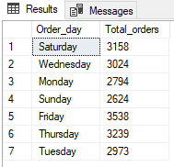

**C. Monthly Trend for Orders**

1. SELECT DATENAME (MONTH, order_date) AS Month_name, COUNT (DISTINCT order_id) AS Total_order

FROM pizza_sales

GROUP BY DATENAME (MONTH, order_date)

ORDER BY Total_order DESC

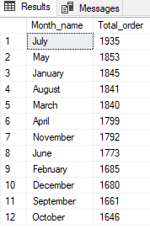

**D. % of Sales by Pizza Category**

1. SELECT pizza_category, SUM (total_price) AS Total_sales, SUM (total_price) * 100 / (SELECT SUM (total_price) FROM pizza_sales WHERE MONTH (order_date) = 1) AS Percent_Total_sales

FROM pizza_sales

WHERE MONTH (order_date) = 1

GROUP BY pizza_category

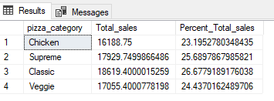

**E. % of Sales by Pizza Size**

1. SELECT pizza_size, CAST (SUM (total_price) AS DECIMAL (10,2)) AS Total_sales, CAST (SUM (total_price) * 100 /

(SELECT SUM (total_price) FROM pizza_sales WHERE DATEPART (quarter, order_date) = 1) AS DECIMAL (10,2)) AS Percent_Total_sales

FROM pizza_sales

WHERE DATEPART (quarter, order_date) = 1

GROUP BY pizza_size

ORDER BY Percent_Total_sales DESC

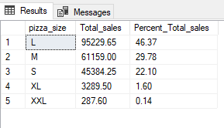

SELECT pizza_size, CAST (SUM (total_price) AS DECIMAL (10,2)) as total_revenue,

CAST (SUM (total_price) * 100 / (SELECT SUM (total_price) from pizza_sales) AS DECIMAL(10,2)) AS PCT

FROM pizza_sales

GROUP BY pizza_size

ORDER BY pizza_size

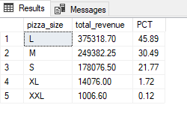

**F. Total Pizzas Sold by Pizza Category**

SELECT pizza_category, SUM (quantity) as Total_Quantity_Sold

FROM pizza_sales

WHERE MONTH (order_date) = 2

GROUP BY pizza_category

ORDER BY Total_Quantity_Sold DESC

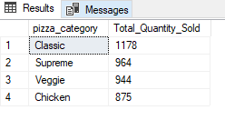

**G. Top 5 Pizzas by Revenue**

1. SELECT TOP 5 pizza_name, SUM (total_price) AS Total_pizza_Name

FROM pizza_sales

GROUP BY pizza_name

ORDER BY Total_pizza_Name DESC

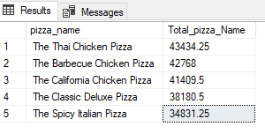

**H. Bottom 5 Pizzas by Revenue**

1. SELECT TOP 5 pizza_name, SUM (total_price) AS Total_pizza_Name

FROM pizza_sales

GROUP BY pizza_name

ORDER BY Total_pizza_Name ASC

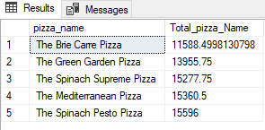

**I. Top 5 Pizzas by Quantity**

1. SELECT TOP 5 pizza_name, SUM (quantity) AS Total_quantity

FROM pizza_sales

GROUP BY pizza_name

ORDER BY Total_quantity DESC

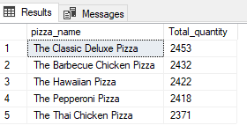

**J. Bottom 5 Pizzas by Quantity**

SELECT TOP 5 pizza_name, SUM(quantity) AS Total_quantity

FROM pizza_sales

GROUP BY pizza_name

ORDER BY Total_quantity ASC

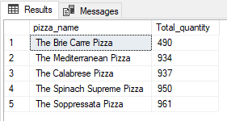

**K. Top 5 Pizzas by Total Orders**

1. SELECT TOP 5 pizza_name, COUNT (DISTINCT order_id) AS Total_order

FROM pizza_sales

GROUP BY pizza_name

ORDER BY Total_order DESC

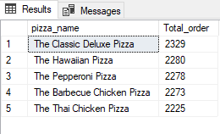

**L. Bottom 5 Pizzas by Total Orders**

14. SELECT TOP 5 pizza_name, COUNT (DISTINCT order_id) AS Total_order

FROM pizza_sales

GROUP BY pizza_name

ORDER BY Total_order ASC

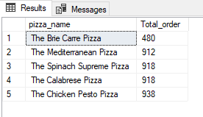

**L. Applying Filter with WHERE Clause**

SELECT Top 5 pizza_name, COUNT (DISTINCT order_id) AS Total_Orders

FROM pizza_sales

WHERE pizza_category = 'Classic'

GROUP BY pizza_name

ORDER BY Total_Orders ASC